- As always, before ever doing any type of code changes, please be sure to have an approved MCM in place for your site. Please use the network approved MCM HERE to submit your site specific MCM for approval ahead of completing any work.
- Go online with the ARSAW or ARSTOW PLC and save the current program and tag values:
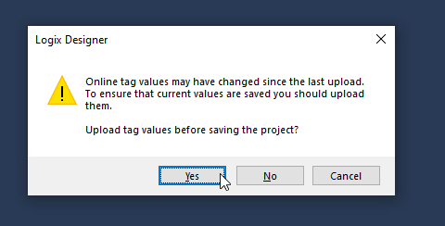
- Go offline from the PLC:
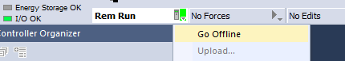
- Import the ARSAW or ARSTOW program as appropriate into the task named MainTask:
NOTE that this is NOT a routine export. It will not import into the MainProgram program or any other program. Be sure to import it into the MainTask task.
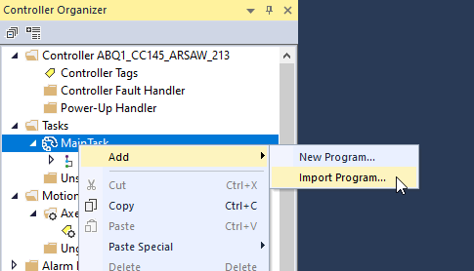
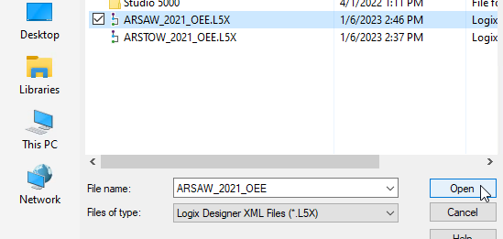
- Click OK on the dialog that pops up after ensuring that you are going to create the new program and schedule it in MainTask:
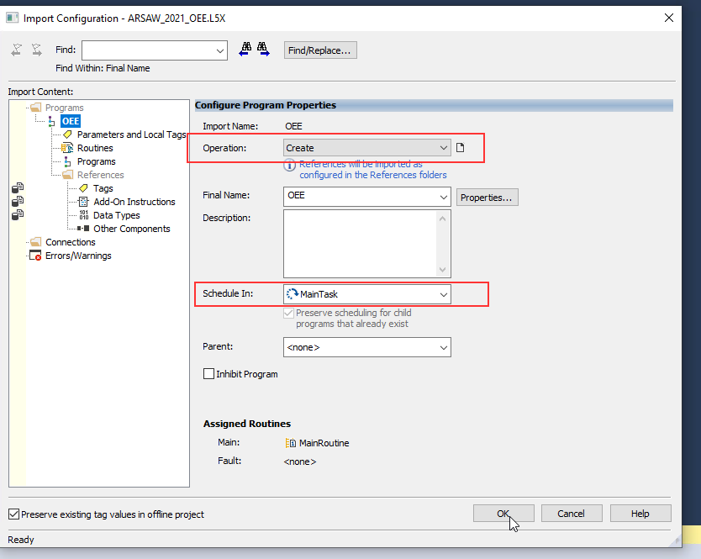
- Download the new program to the PLC:
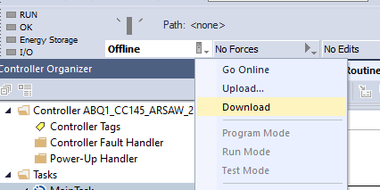
- The PLC part is done. Now we need to connect the Measuring Points to the OEE platform.
- Retrieve the name of the ARSAWs and/or ARSTOWs from the EMS Hub. Click Self-Service Tools then Device Monitoring.
  - NOTE: If the connection has not yet been established by EMS, a SIM will need to be submitted to them in order to establish the connection so the device shows up in the HUB. The SIM can be submitted HERE.
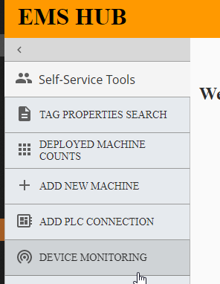
- Select your site and note the name of the ARSAWs and/or ARSTOWs. The easiest way is usually to export the list of devices:
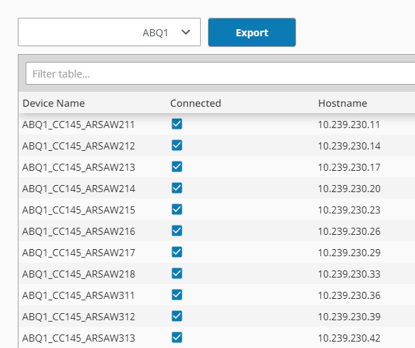
- Go to the RMESD Add/Edit/Audit Dashboard and Click Tools and then EMS Refresh
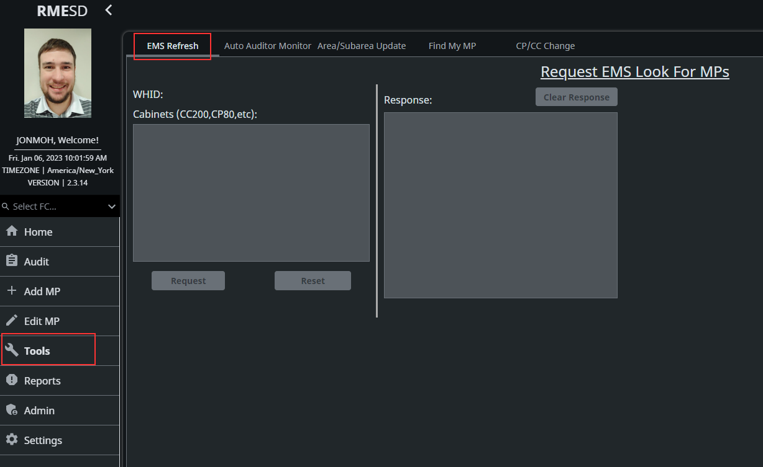

Select your FC in the Lefthand menu, and input a comma-separated list of ARSAWs and/or ARSTOWs in the Cabinets textbox.
NOTE: EMS appends WHID_ to the device name for displaying, but this is not really part of the device name. You should remove this prefix before pasting them into the text box or they will not connect. For example in the list shown above, ABQ1_CC145_ARSAW211 should be CC145_ARSAW211.
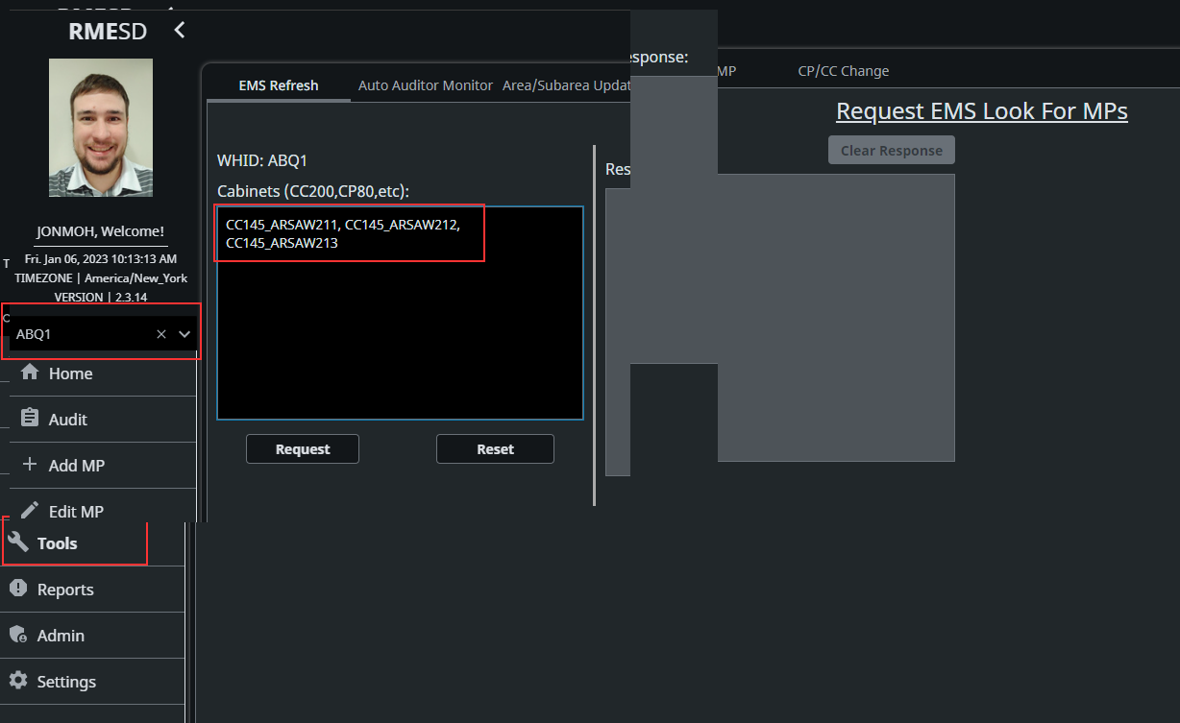
- Click Request. If you are refreshing the connection to more than a few devices, this may take many minutes to complete. Please be patient.
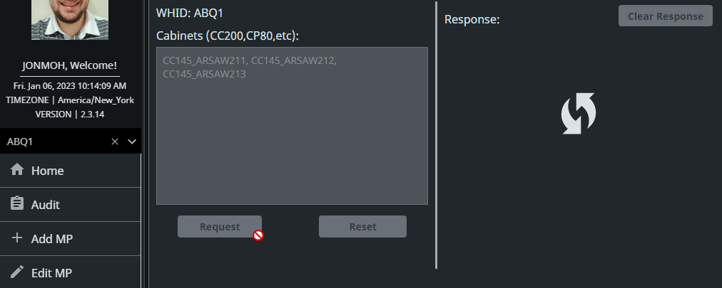
- Wait for the ‘Response’ field to populate, and verify that the MPs were successfully found.
  - Example of successful refresh:
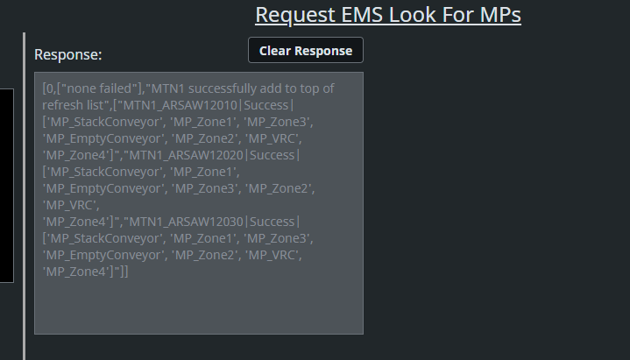
  - Example of unsuccessful refresh:
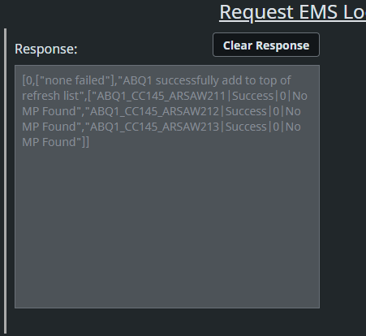
- Once the controllers have successfully been refreshed, it may take up to 20 minutes for the Measuring Points to make it all the way through the pipeline. It is suggested to wait 20 minutes before proceeding to avoid confusion about whether the MPs were successfully refreshed or not.
- In the same Add/Edit/Audit Dashboard, click on Add MP in the lefthand menu. Select your Whid in the first dropdown that appears, if it not already selected. Select MPP in the next dropdown, and then begin working through all the ARSAWs and/or ARSTOWs that you have connected.
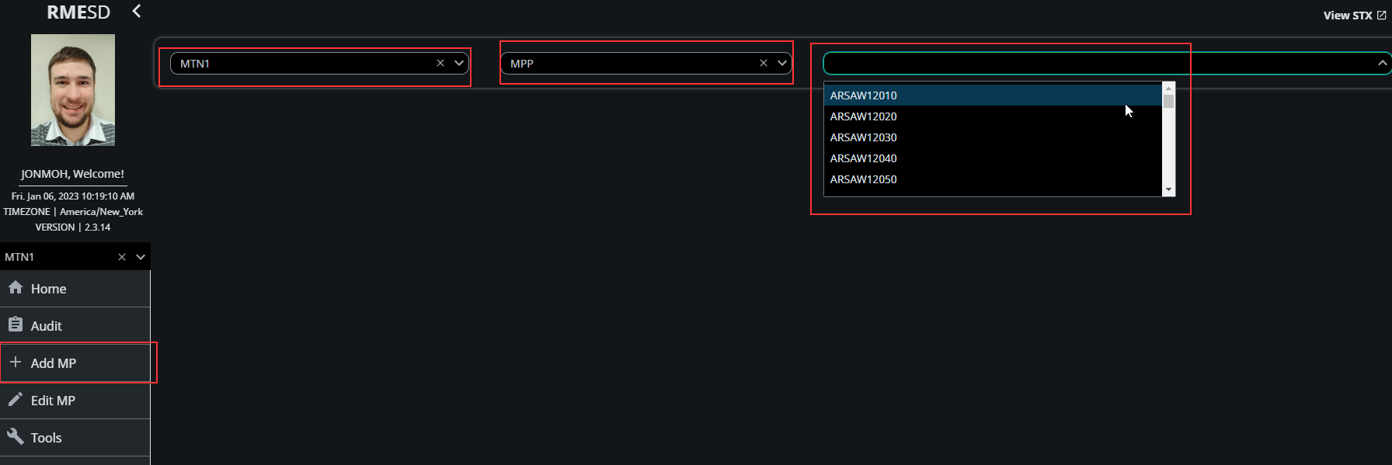
- Each ARSAW and ARSTOW has 7 or 3 Measuring Points associated with it, respectively. To reduce the amount of manual entry, toggle the Bulk Add switch that appears when you select and ARSAW or ARSTOW.
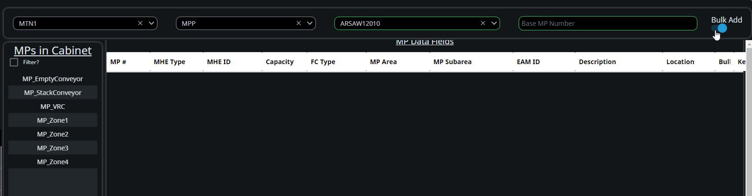

- Toggling the Bulk Add switch will cause a new text field to show up labeled “Base MP Number”. Base MP number is a 2-digit number beginning at 00 that uniquely identifies the machine. It is the xx in the naming convention at the bottom. Note that ARSAWs and ARSTOWs will use the same Base MP Numbers (e.g. ABQ1 will have an ARSAW with base number 02 and also an ARSTOW with base number 02.)
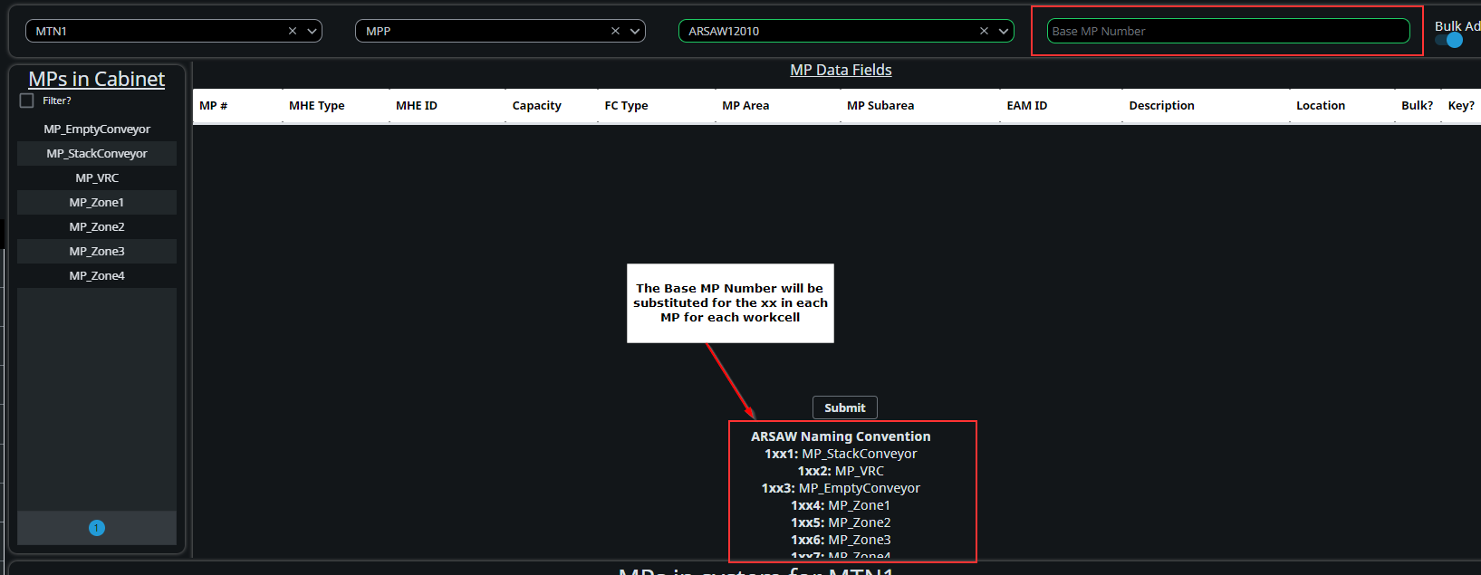
- Enter the base number into the text field, beginning at 00 and work up through all the ARSAWs and/or ARSTOWs that need added. When you type a new base number, the 3 or 7 MPs will auto-populate in the center of the screen. Change anything that you wish to change (e.g. if you want to add location or EAM ID), and then click submit.
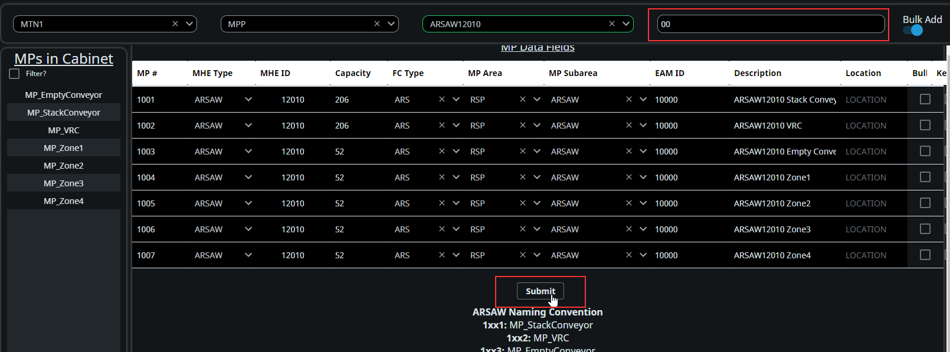
- Repeat steps 14-17 for each ARSAW and/or ARSTOW that you need to add.

